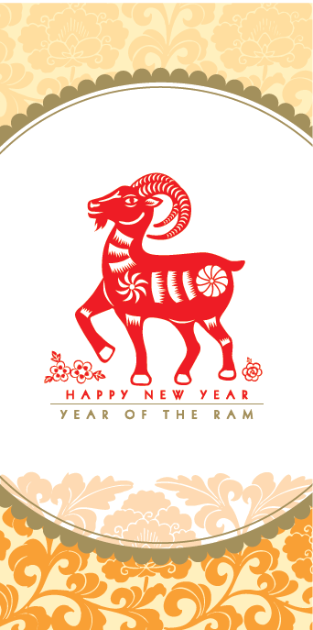 | 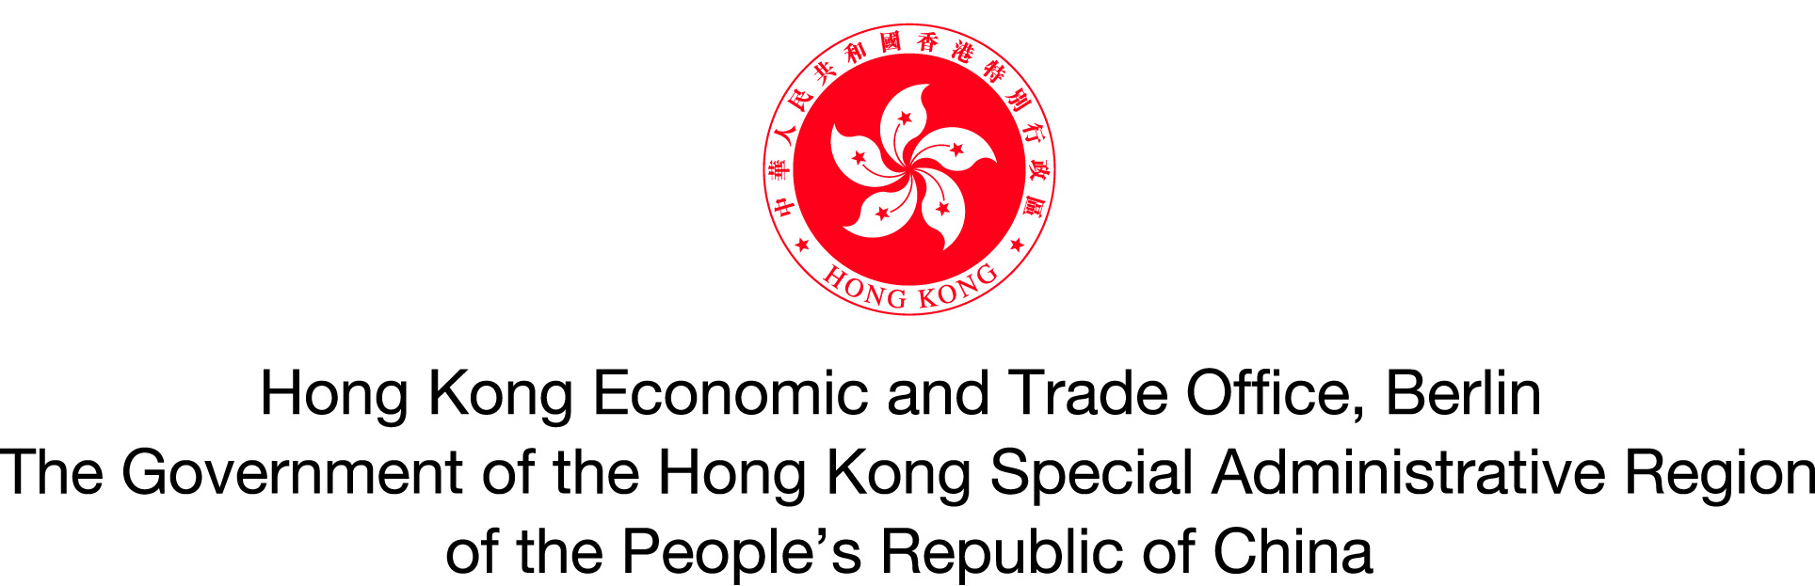  Ms Betty Ho  Director, Hong Kong Economic and Trade Affairs (Central and Eastern Europe)  The Government of the Hong Kong Special Administrative Region  of the People’s Republic of China  and  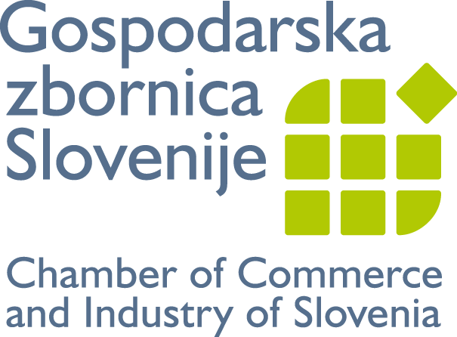  Mr Samo Hribar Milič  President  Chamber of Commerce and Industry of Slovenia  request the pleasure of your company  at a buffet reception  on the occasion of  the Chinese New Year of the Ram  at 12:30  on Friday, 13 February 2015  at  Chamber of Commerce and Industry of Slovenia  Dimičeva 13, Ljubljana | Programme  12:30 Registration  13:00 Welcome Remarks  13:20 Musical Performance  13:40 Buffet Reception  14:30 End of Reception  Dress code: Business attire  RSVP by Tuesday, 4 February 2015 to online registration form  http://www.gzs.si/slo/skupne_naloge/mednarodno_poslovanje/66527  or  e-mail CEMP@gzs.si.

